

2025

SARVESH PRATAP YADAV

**Prediction of IRIS flower using Machine Learning Model.**

**Problem Statement –** In this project we make prediction of the physical parameters of   
three species of Iris flower — Iris-Versicolor, Iris-Setosa and Iris-Virginica. The numeric   
parameters which the dataset use contains are Sepal width, Sepal length, Petal width and   
Petal length. In this Project we will be predicting the classes of the flowers based on these   
parameters. The data consists of continuous numeric values which describe the   
dimensions of the respective features. We will be training the model based on these

features.

**Steps to be taken in the Project is sub-divided into the following sections.**

**These are:**

• Load the necessary libraries such as Numpy , Pandas , sklearn etc.

• Loading the dataset as csv file and showing first ten rows.

• Drop the unnecessary columns from the data.

• Calculate statistical values and round them up to 3 decimal places.

• Checking for null values and return their sum of numbers of true values in

each column.

• Handle the null by mean of all values fill into them.

• Extracting all information about data.

• Checking shape of data and checking unique values in dependent variable.

• Visualization on different species of Iris flower using Python data visualization.

• Data preprocessing or (Data cleaning) performed by the one hot encoding   
 in this process we change categorical data into numerical data and the   
 technique is called feature Engineering.

• Splitting the cleaned data into dependent and independent variables.

• Splitting the data into train and test sets with train_test_split using sklearn   
 library.

• Import different kind of Classification Models and Train that model with the   
 help of .fit().

• Predicting the trained models and then checking their accuracy score and   
 confusion metrics of the model using confusion metrics & accuracy score.

• Then recall the train_test_split and split the data into training and testing

set with different models.

• Then predicting the trained models and checking the accuracy of model and   
 check the accuracy difference.

• And finally predict whether the classification of different species of Iris is generated

or not.

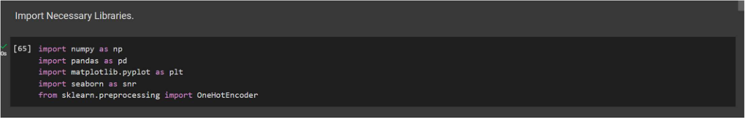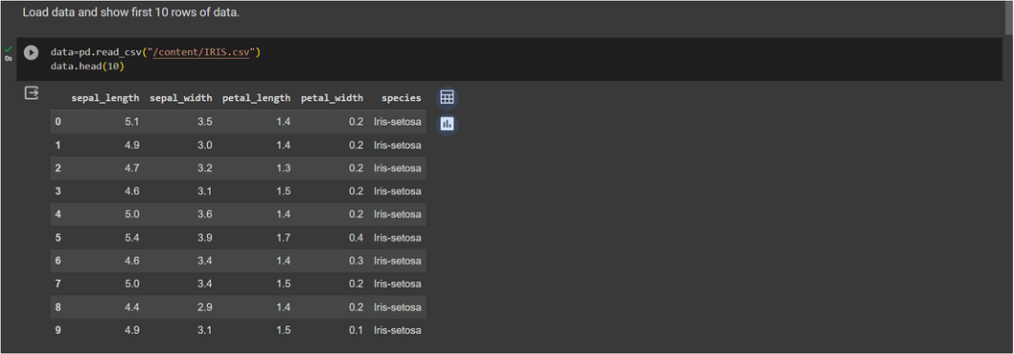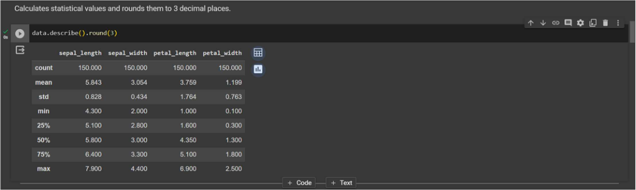2025

SARVESH PRATAP YADAV

➢**Step-1 -** Loading Necessary Libraries used in machine learning.

➢**Step-2 -** Loading the dataset as csv file and showing first ten rows.

➢**Step-3 -** Calculate statistical values and round them up to 3 decimal places.

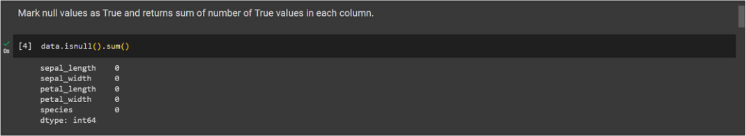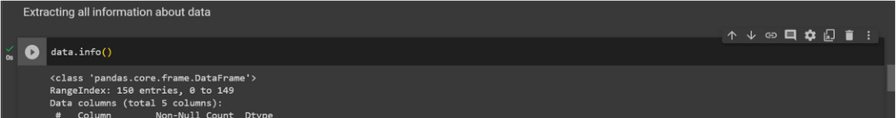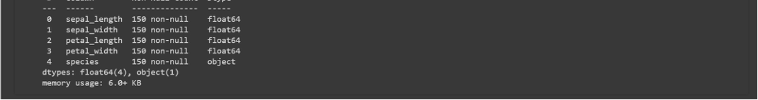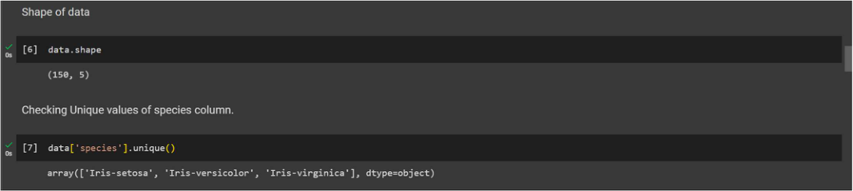

SARVESH PRATAP YADAV

➢**Step-4 –** Checking for null values and return their sum of numbers of true values

in each column.

➢**Step-5 –** Extracting all information about data.

➢**Step-6 -** Checking shape of data and checking unique values in dependent

variable.

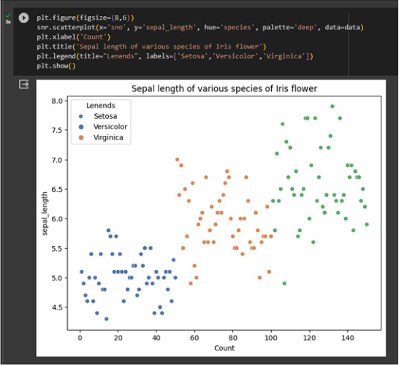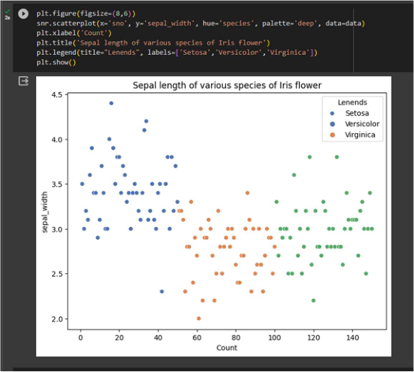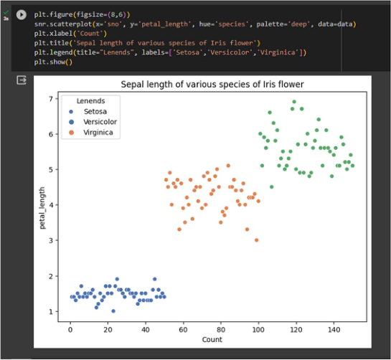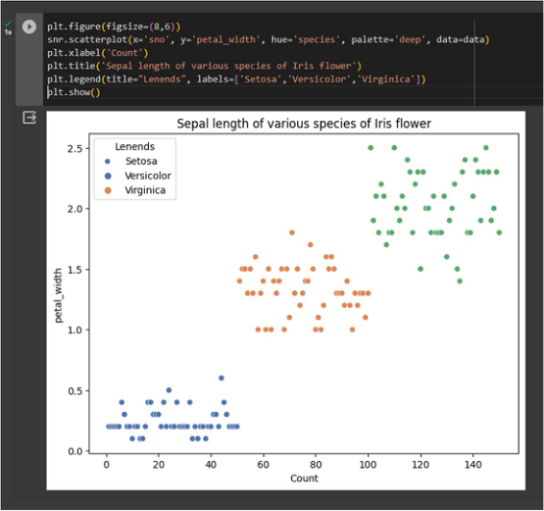

SARVESH PRATAP YADAV

**Step-7 -** Visualization on different species of Iris flower using Python Data

Visualization.

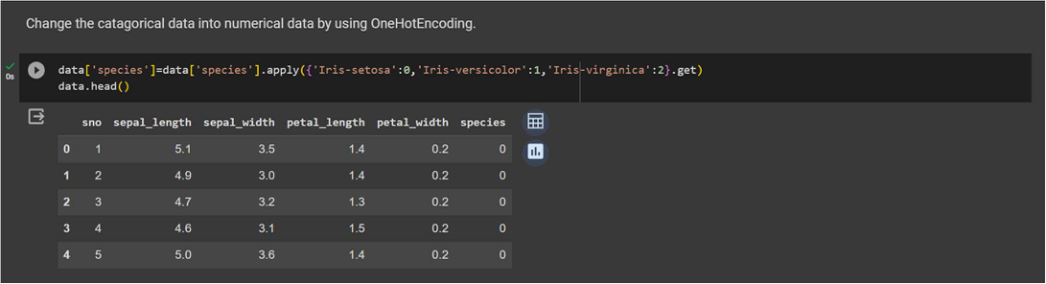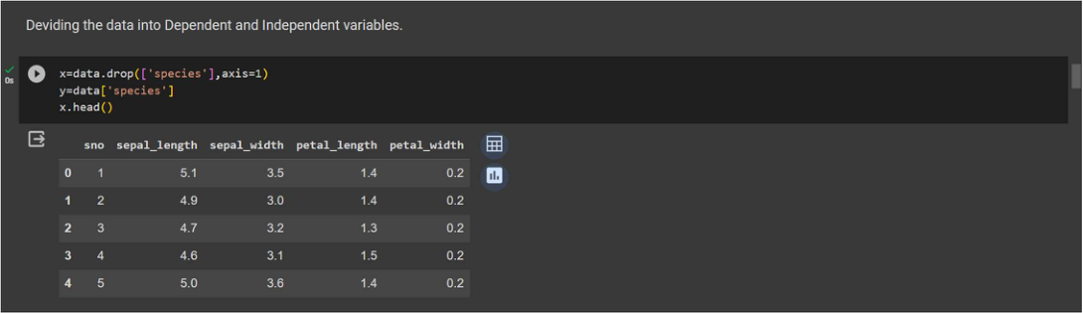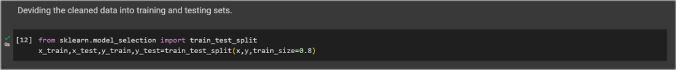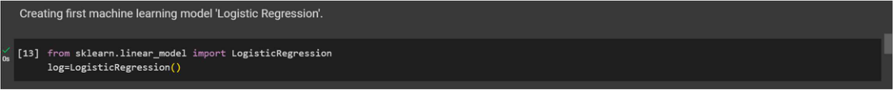

SARVESH PRATAP YADAV

➢**Step-8 –** Data preprocessing or (Data cleaning) performed by the one hot

encoding in this process we change categorical data into numerical data and the

technique is called feature Engineering.

➢**Step-9 –** Splitting the cleaned data into dependent and independent variables.

➢**Step-10 –** Splitting the data into train and test sets with train_test_split using

sklearn library.

➢**Step-11 –** Import first machine learning model ‘Logistic regression’.

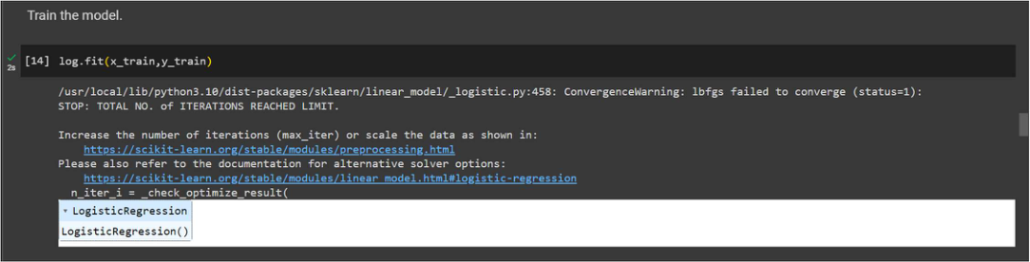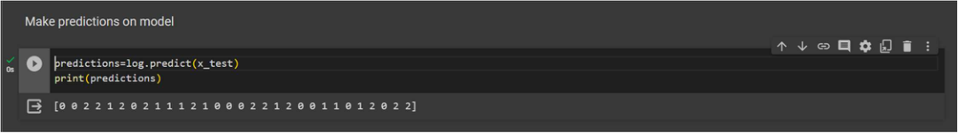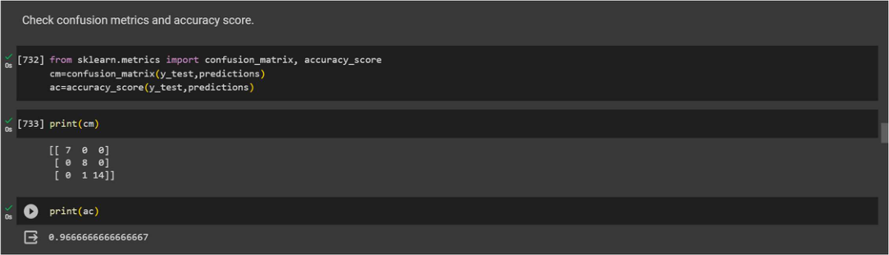

2025

SARVESH PRATAP YADAV

➢**Step-12 –** Train the model using .fit() function.

➢**Step-13 –** Make predictions on model using .predict() function.

➢**Step-14 –** Check the accuracy score and print a confusion metrics with

confusion metrics & accuracy score.

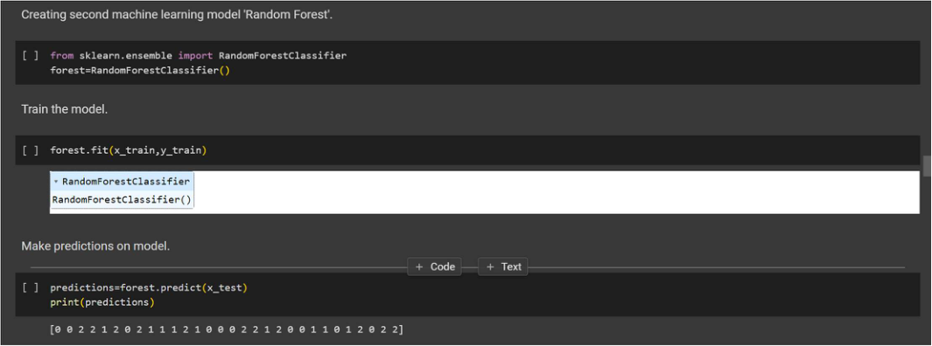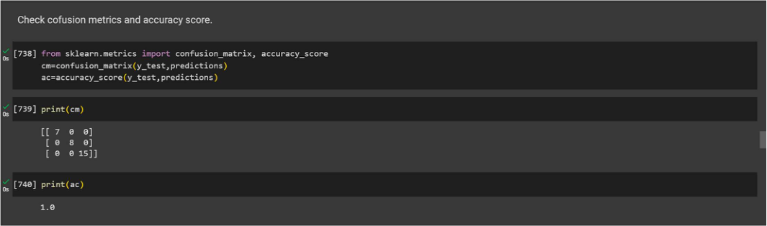

SARVESH PRATAP YADAV

➢**Step-15 –** Import the Second Machine Learning Model ‘Random Forest’ and train

model and then make prediction.

➢**Step-16 –** Print a confusion metrics and check accuracy score for Random forest

Model.

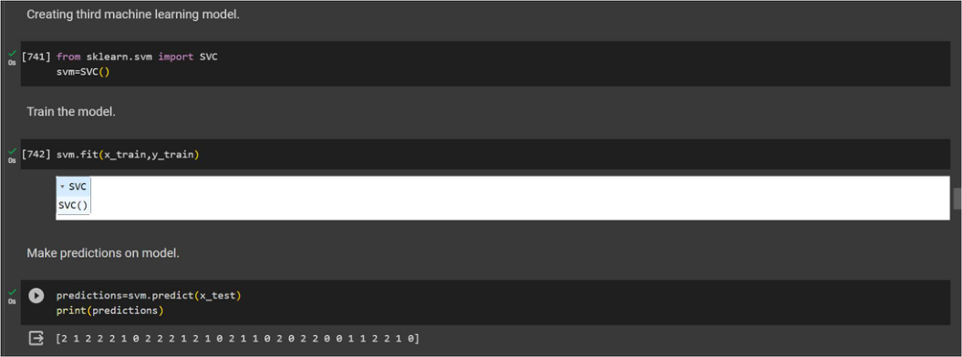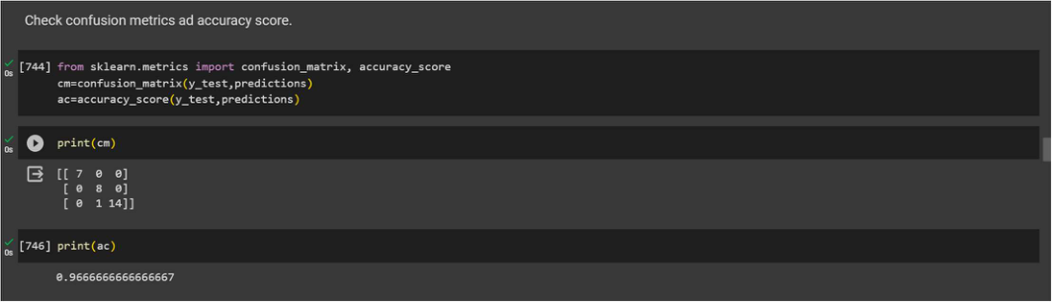

SARVESH PRATAP YADAV

**Step-17 –** Import the Third Machine Learning Model Support Vector Machine   
and train model and then make prediction.

**Step-18 –** Print a confusion metrics and check accuracy score for Support Vector

Machine Model.

**Conclusion –** This project demonstrats the end-to-end process of building a machine   
learning model for Iris flower classification. It includes data preprocessing, exploratory   
data analysis, and model training. the first model is used in this   
project is Logistic Regression, second used is Random Forest, and   
third is Support vector Machine and model was trained with an   
accuracy of 97% approximate.